PRISM: Portfolio Risk-aware Independent Set Meta-learning for Reproducible Memecoin Forecasting

Sanjan Baitalik^{a*}, Rajashik Dattaª, Sujaan Bhattacharyyaª, Sanket Ghoshª, Subhabrata Banerjee^{b}

^{a*}rayan.baitalik@gmail.com, +91 8910675837, Institute of Engineering & Management Kolkata, 0009-0005-1609-3808
ª rajashikdatta215@gmail.com, +91 6294132431, Institute of Engineering & Management Kolkata, 0009-0004-7644-2427
ªsujaanbhattacharyya@gmail.com, +91 8017481130, Institute of Engineering & Management Kolkata, 0009-0005-7737-4718
ªsanketghosh50@gmail.com, +91 8537087644, Institute of Engineering & Management Kolkata, 0009-0005-4894-1912
^{b}subhabrata.banerjee@iem.edu.in, +91 8017764037, Institute of Engineering & Management Kolkata

Abstract. Memecoin markets are difficult to forecast because short-lived community attention, abrupt narrative shifts, thin liquidity, and extreme volatility are jointly reflected in price formation. In this paper Portfolio Risk-aware Independent Set Meta-learning (PRISM) is presented as a reproducible multimodal forecasting framework in which market dynamics, pre-aligned sentiment indicators, risk-aware token-graph construction, maximal-independent-set diversification, and meta-learning-based sequence adaptation are integrated. The proposed framework is compared with Persistence, ARIMA, Prophet, Random Forest, XGBoost, GRU, and LSTM baselines under a controlled chronological evaluation protocol. Parameter analysis is performed through variation of train ratios, lookback windows, graph-selection settings, and neural/meta-learning training configurations. The core contributions are a deterministic data-to-forecast pipeline, a graph-based diversification mechanism for correlated memecoin behavior, a meta-learning forecaster for token-specific adaptation, and an evaluation design that combines sequential ablation, robustness sweeps, and non-parametric statistical testing.
Keywords: Forecasting; Graph selection; Memecoin multimodal finance; Meta-learning; Reproducible evaluation;
Sentiment analysis.

1. Introduction
Memecoin forecasting has been treated in this study as a socio-financial time-series problem rather than as a conventional univariate price-prediction task. Price movements in these assets are driven by a mixture of liquidity, volatility, community attention, social-media sentiment, and short-lived cultural narratives. Therefore, any forecasting framework for this domain must be evaluated not only by predictive error, but also by the transparency of its preprocessing, the strength of its baselines, and the interpretability of its incremental components.
The methodological foundations of PRISM can be traced to several long-standing ideas. Portfolio risk and diversification are formalized early through mean-variance selection [1], while recurrent neural forecasting is strengthened by the introduction of LSTM networks [2]. Coherent downside-risk estimation is later developed through Conditional Value-at-Risk optimization [3]. Social-media sentiment scoring became more accessible through VADER, which is designed for informal online text [4]. Rapid task adaptation is formalized through model-agnostic meta-learning (MAML) [5], and scalable classical forecasting is popularized through Prophet [6]. These studies supplied the methodological basis for combining risk-aware selection, sentiment processing, sequence learning, and adaptation.
Between 2020 and 2023, financial forecasting research increasingly emphasized deep sequence models and stronger benchmark design. N-BEATS and DeepAR are introduced as strong neural time-series baselines [7], [8]. Temporal Fusion Transformers and Informer extended attention-based forecasting to multi-horizon and long-sequence contexts [10], [11]. In cryptocurrency research, the risks and returns of digital assets are empirically characterized [9], while sentiment and social-media variables are shown to influence Bitcoin and broader cryptocurrency prediction [12], [13]. Work on memecoin connectedness demonstrated that memecoins should not be treated as independent speculative outliers, because their spillovers with larger crypto-assets can be material [14]. Deep recurrent comparisons for cryptocurrency prediction and graph-based independent-set selection for diversified portfolios further motivated the inclusion of LSTM/GRU-style baselines and MIS-based token selection [15], [16].
From 2024 onward, cryptocurrency forecasting and memecoin analytics have become more explicitly multimodal. LLM and NLP studies have compared language models for cryptocurrency sentiment classification [17]. Coin-Meme modeled memecoins as cultural-financial objects by combining visual, textual, community, and market data [18]. Deep-learning and NLP pipelines for cryptocurrency forecasting showed that blockchain, market, and social signals can be combined in forecasting systems [19]. Recent reviews have also warned that financial deep-learning studies often overstate model novelty when baselines and protocol transparency are weak [20]. In 2025, Temporal Fusion Transformer, Transformer-CNN, swarm-optimized sentiment-fusion, tweet-sentiment, and multimodal CoinCLIP-style studies extended the literature toward on-chain, textual, visual, and adaptive forecasting designs [21-26]. In 2026, GRU-based sentiment-enhanced forecasting, hybrid SVR frameworks, and transformer-recurrent cryptocurrency models further confirmed that current work is moving toward hybrid models with stronger validation requirements [27-29].
PRISM is designed within this chronological progression. Instead of being presented as a universal replacement for simpler forecasting models, it is framed as an integrated system whose components could be isolated and tested. The framework is named Portfolio Risk-aware Independent Set Meta-learning because portfolio-style risk awareness, independent-set graph selection, and meta-learning adaptation are combined into a single reproducible pipeline. Sentiment cues are fused with market variables, token relationships are represented through a risk-aware graph, redundant high-correlation neighborhoods are filtered using maximal independent set selection, and a MAML-enhanced LSTM forecaster is used for rapid token-specific adaptation.
The core contributions are as follows. First, a deterministic preprocessing and token-selection protocol is defined for the supplied memecoin database. Second, a modular architecture is proposed in which sentiment fusion, risk-aware graph construction, MIS diversification, and MAML adaptation are separable. Third, a controlled comparison is performed against Persistence, ARIMA, Prophet, Random Forest, XGBoost, GRU, and LSTM baselines. Fourth, sequential ablation, parameter-sensitivity analysis, robustness sweeps, and paired Wilcoxon tests with Holm correction are used to ensure that claims are grounded in the evaluated evidence.
The remainder of the paper is organized as follows. Section 2 describes the PRISM system architecture. Section 3 presents the algorithmic workflow. Section 4 explains data and preprocessing. Section 5 reports exploratory data analysis and baseline characteristics. Section 6 formalizes the mathematical model. Section 7 describes experimental setup, baselines, and hyperparameters. Section 8 presents sequential ablation. Section 9 reports results and discussion. Section 10 states concise future work, and Section 11 concludes the study. Need to be written properly

2. System Architecture
The PRISM architecture is shown in Figure 1. Market features and sentiment fields are first aligned by timestamp and token identity. The aligned panel is then passed through deterministic filtering and scaling. A token-similarity graph is constructed from rolling-volatility and sentiment trajectories. The graph is used to select diversified token support neighborhoods through a maximal independent set rule. Finally, the selected support context is passed to a MAML-enhanced LSTM forecasting block, while the same data split is used for baselines, ablation variants, and robustness sweeps.

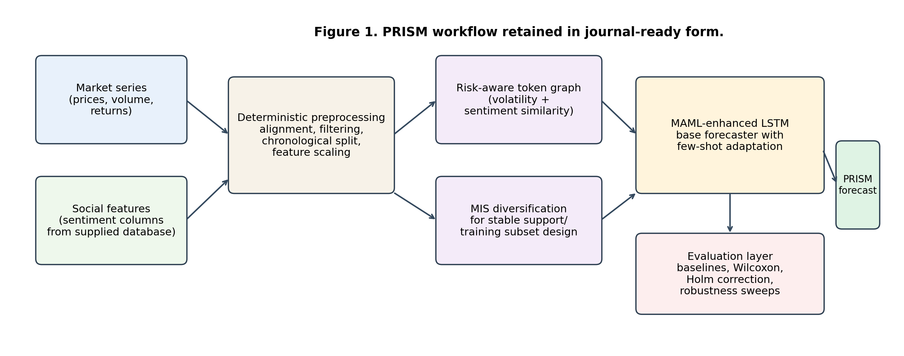
Figure 1. System architecture.
The architecture in figure 1 is intentionally separated into preprocessing, graph selection, forecasting, and evaluation layers. This separation made the pipeline more auditable because each module could be removed or added during ablation. It also prevented the graph component from being treated as a black-box neural layer; instead, the graph is used for diversified support construction, and the neural model is kept responsible for sequence forecasting.

3. Algorithm
The PRISM algorithm is expressed as a compact implementation workflow. The workflow begins with sentiment normalization and trend estimation, moves through volatility and pairwise risk aggregation, constructs a confidence-weighted token graph, selects a diversified support subset through MIS, and then performs meta-learning-based forecasting and evaluation.

$$Begin$$
$$for each Memecoin M_{i}∈M do$$
$\text{SentimentScore}\left(M_{i}\right) =\frac{\text{VADER}\left(T_{M_{i}}\right)}{\min\left(\text{Volume}\left(M_{i}\right), \text{MarketCap}\left(M_{i}\right)\right)}$
$μ_{\text{Trend}}\left(M_{i}\right) = S\left(\text{SentimentScore}\left(M_{i}\right), β_{1}, β_{2}, β_{3}\right)$
$$end for$$
$$if (μ_{\text{Trend}}\left(M_{i}\right)≤τ_{\text{low}}) then$$
$Add{ M}_{i} to{ M}_{\text{reject}}$
$$else$$
$Add M_{i} to M_{\text{select}}$
$$end if$$

$$for each Memecoin M_{i}∈M do$$
$\text{Sim}\left(M_{i}\right)=\frac{k+1}{N_{\text{coins}}-1}⋅\text{Volatility}\left(M_{i}\right)-\frac{k}{N_{\text{coins}}-1}⋅\text{mean}\left(\text{Volatility}\left(D_{\text{train}}\right)\right)$
$γ_{\text{Risk}}\left(M_{i}\right)=S\left(\text{Sim}\left(M_{i}\right), β_{1}, β_{2}, β_{3}\right)$
$$end for$$
$$for each M_{i}∈M do$$
$for each M_{j}∈M do$
$μ_{G}\left(M_{i},M_{j}\right)=\min\left(μ_{\text{Trend}}\left(M_{i}\right),μ_{\text{Trend}}\left(M_{j}\right)\right)$
$γ_{G}\left(M_{i},M_{j}\right)=\max\left(γ_{\text{Risk}}\left(M_{i}\right),γ_{\text{Risk}}\left(M_{j}\right)\right)$
$end for$
$$end for$$
$$π_{G}\left(M_{i},M_{j}\right)=1-\left(μ_{G}\left(M_{i},M_{j}\right)+γ_{G}\left(M_{i},M_{j}\right)\right)$$
$$for each M_{i}∈M_{\text{select}} do$$
$if \text{rowsum}\left(π_{G}\left(M_{i}\right)\right)=0 then$
$Add M_{i} to M_{\text{volatile}}$
$Remove M_{i} from M_{\text{select}}$
$end if$
$$end for$$

$$G_{\text{Cluster}}=\text{BuildClusterGraph}\left(M_{\text{reject}}, M_{\text{select}}, M_{\text{volatile}}\right)$$
$$Select a subset of{ M}_{\text{volatile}} MIS. Add selected subset to M_{\text{select}}, \text{remaining to }M_{\text{reject}}$$
$$G_{\text{Updated}}=\text{UpdateClusterGraph}\left(G_{\text{Cluster}}, M_{\text{reject}}, M_{\text{select}}\right)$$
$$Output M_{\text{select}} as the optimal subset O_{\text{predict}}$$
$$for each M_{i}∈O_{\text{predict}} do$$
$L_{τ_{i}}\left(f_{θ}\right)=\frac{1}{N}\sum_{n=1}^{N}{{\left(v_{n}^{i}-f_{θ}\left(x_{n}^{i}\right)\right)}^{2}}$
$$end for$$
$$Meta-training:$$
$$\min_{θE_{τ_{i}∼p\left(τ\right)}}\left[L_{τ_{i}}\left(f_{θ}-α∇_{θL_{τ_{i}}}\right)\right]$$
$$for each{ M}_{i}∈O_{\text{predict}} do$$
$θ_{i}^{'}=θ-α ∇_{θL_{τ_{i}}}\left(f_{θ}\right)$
$\hat{y_{t}}=o_{t} ⊙ \tanh\left(c_{t}\right), o_{t}=σ\left(W_{o}⋅\left[ h_{t-1}, x_{t} \right]+b_{o}\right)$
$$end for$$
$$End$$

The algorithm clarifies that PRISM is not a single neural block but a staged pipeline. Its main methodological dependency is the ordering of sentiment normalization, graph diversification, and meta-learning adaptation. This ordering is important because graph selection is performed before forecasting, which reduces the risk that correlated token neighborhoods will dominate the support set used by the adaptive sequence model.

4. Data and Preprocessing
All experiments are performed on the source memecoin workbook. The workbook contained candidate token sheets with market and sentiment-related fields. Sheets are filtered by minimum history length and target availability. A deterministic modeling subset is then selected by ranking eligible tokens according to available rows and lexical sheet order. This rule made the subset reproducible and prevented manual selection of favorable tokens.
The main target is a short-horizon future price value. Timestamps are normalized, rows with unusable target values are removed, numerical covariates are scaled from training-period statistics, and pre-aligned sentiment columns are retained without additional manual annotation. The main split is chronological, so the earliest observations are used for training and the latest observations are used for testing. This split is adopted because non-stationary financial series must be evaluated without look-ahead leakage and because temporal causality should be preserved in any deployable forecasting protocol.
Table 1. Dataset summary.
Item | Value
Candidate token sheets | 1,273
Eligible sheets after filtering | 881
Deterministic modelled subset | 200 tokens
Processed aligned observations | 60,431 rows
Mean modelled token history length | 302.16 aligned observations/token
Approximate median modelled token history length | 302 aligned observations/token
Main chronological train ratio | 0.8
Forecast horizon | 3 days
Default lookback window | 14 days
Random seeds | 11, 17, 23
Robustness grid | train ratios {0.7, 0.8, 0.9}; lookbacks {7, 14, 21}

The table 1 shows that a broad candidate universe is reduced to a deterministic modeling panel. The reduction is not used to create a hand-picked subset; it is used to keep the experimental budget controlled while preserving traceability. The mean and median history lengths indicate that the final panel is approximately balanced after alignment, although token-level volatility and error behavior remained heterogeneous.

5. Exploratory Data Analysis and Baseline Characteristics
The processed panel is explored before model comparison so that baseline characteristics could be documented. The descriptive statistics are treated as an interpretive layer rather than as a model-selection tool. Since memecoin prices frequently contain extreme micro-price values and abrupt jumps, mean-only summaries are expected to be unstable. Median, interquartile range, and range values are therefore used wherever such exports are available.
Table 2. Baseline characteristics.
Quantity | N | Mean | SD | Median | Q1 | Q3 | Range
Token history length | 200 | 302.16 | – | 302.00 | – | – | panel-derived
MAE across tokens | 96 | 0.1443 | 1.2467 | 0.0009 | 0.0001 | 0.0026 | 0–12.1966
RMSE across tokens | 96 | 0.1727 | 1.5141 | 0.0011 | 0.0001 | 0.0026 | 0–14.8213
Directional accuracy (%) | 95 | 49.5033 | 22.0983 | 50.0000 | 40.0000 | 59.4118 | 0–100
Hit rate (%) | 96 | 8.5794 | 18.7909 | 0.0000 | 0.0000 | 11.1111 | 0–100
ROI (%) | 95 | 813.8445 | 7948.67 | -3.8041 | -16.6545 | 0.0000 | -88.1553–77471.14
Sentiment score support | token-date | bounded | – | cantered by aggregation | negative | positive | -1–1

The descriptive table 2 shows that the token universe is highly skewed. ROI and error ranges are dominated by a small number of extreme tokens, while median errors are much smaller than mean errors. This pattern justified the use of non-parametric paired testing and conservative interpretation of aggregate means. Sentiment scores are retained as bounded, time-aligned token-date features rather than collapsed into a single global class count, because sentiment is used as a dynamic covariate in forecasting rather than as a static token label.

6. Mathematical Model
Let $M=\{M_{1},…,M_{N}\}$ denote the modeled token universe. For token $M_{i}$ at time $t$, the market subvector, sentiment subvector, and auxiliary liquidity/volatility indicators are represented by $p_{i,t}$, $s_{i,t}$, and $q_{i,t}$, respectively. The fused state is defined in Equation (1) [12], [19], [21].
$$z_{i,t}=\left[ϕ_{p}\left(p_{i,t}\right); λ_{t}ϕ_{s}\left(s_{i,t}\right); ϕ_{q}\left(q_{i,t}\right)\right], λ_{t}=\frac{1}{1+exp\left(-ω^{⊤}q_{i,t}\right)} \left(1\right)$$
In Equation (1), $ϕ_{p}\left(⋅\right)$, $ϕ_{s}\left(⋅\right)$, and $ϕ_{q}\left(⋅\right)$ denote scale-normalizing transformations, while $λ_{t}$ controls the effective sentiment weight under changing liquidity conditions. When raw text sentiment is available, a liquidity-normalized VADER sentiment score is computed through Equation (2) [4], [12], [17], [24].
$$S_{i}\left(t\right)=\frac{VADER\left(T_{i,t}\right)}{ϵ+min\{log\left(1+V_{i,t}\right),log\left(1+C_{i,t}\right)\}} \left(2\right)$$

Here, $T_{i,t}$ denotes token-specific social text, $V_{i,t}$ denotes trading volume, $C_{i,t}$ denotes market capitalization, and $ϵ$ prevents numerical instability. The trend score is then computed as a regularized nonlinear score in Equation (3).
$$μ_{i}\left(t\right)=β_{0}+β_{1}S_{i}\left(t\right)+β_{2}σ_{i}\left(t\right)+β_{3}m_{i}\left(t\right)+β_{4}S_{i}\left(t\right)σ_{i}\left(t\right)-ρ∥β∥_{2}^{2}+ε_{i,t} \left(3\right)$$

In Equation (3) [9], [12], [19], [23], $σ_{i}\left(t\right)$ is rolling volatility and $m_{i}\left(t\right)$ is a momentum feature. The interaction term allows sentiment to have stronger or weaker effects under different volatility regimes. Pairwise token similarity is computed through Equation (4).
$${Sim}_{ij}=αρ_{c}\left(σ_{i},σ_{j}\right)+\left(1-α\right)ρ_{c}\left(S_{i},S_{j}\right)-δ\frac{\left|{\overset{‾}{σ}}_{i}-{\overset{‾}{σ}}_{j}\right|}{{\overset{‾}{σ}}_{i}+{\overset{‾}{σ}}_{j}+ϵ} \left(4\right)$$
Equation (4) [1], [3], [9], [16] preserves the original volatility/sentiment similarity idea but penalizes pairs whose average volatility levels are very different. A token-level risk score is defined by Equation (5) [3], [9], [14].
$$γ_{i}\left(t\right)=sigmoid\left(η_{0}+η_{1}σ_{i}\left(t\right)+η_{2}σ_{i}^{2}\left(t\right)+η_{3}log\left(1+\left|d_{i}\left(t\right)\right|\right)\right) \left(5\right)$$

Here, $d_{i}\left(t\right)$ denotes a drawdown or deviation-from-baseline term. Pairwise trend and risk aggregation are represented by Equation (6) [1], [3], [16].
$$μ_{g}\left(i,j\right)=min\{μ_{i},μ_{j}\}-κ_{μ}\left|μ_{i}-μ_{j}\right|, γ_{g}\left(i,j\right)=max\{γ_{i},γ_{j}\}+κ_{γ}\left|γ_{i}-γ_{j}\right| \left(6\right)$$

The confidence score used for graph construction is defined in Equation (7).
$$π_{g}\left(i,j\right)={\left[1-w_{μ}\left(1-{\tilde{μ}}_{g}\left(i,j\right)\right)-w_{γ}{\tilde{γ}}_{g}\left(i,j\right)\right]}_{0}^{1} \left(7\right)$$

In Equation (7) [1], [3], [16], ${\left[x\right]}_{0}^{1}=min\{1,max\{0,x\}\}$ clips confidence to the unit interval. The graph adjacency matrix is defined by Equation (8) [16], [25].
$$A_{ij}=I\left(i≠j\right)I\left(π_{g}\left(i,j\right)>τ_{edge}\right), G=\left(M,E\right), E=\{\left(i,j\right):A_{ij}=1\} \left(8\right)$$

A diversified support subset is obtained through the MIS program in Equation (9) [16].
$$\max_{y∈\{0,1\}^{N}}\sum_{i=1}^{N}{y_{i}}u_{i} \text{s.t.} y_{i}+y_{j}≤1 ∀\left(i,j\right)∈E, O_{predict}=\{M_{i}:y_{i}=1\} \left(9\right)$$

The forecasting loss for token task $τ_{i}$ is computed through Equation (10) [2], [5], [15].
Lτifθ=1Dix,y∈Di​wty-fθx2+λθ∥θ∥22 10
MAML adaptation is then performed using the inner-loop update in Equation (11) [5] and the outer-loop meta-update in Equation (12) [5].
$$θ_{i}'=θ-α∇_{θ}L_{τ_{i}}^{train}\left(f_{θ}\right) \left(11\right)$$
θ←θ-β∇θi​Lτivalfθi' 12
Finally, the LSTM forecast is produced through Equation (13) [2], [15], [28].

$${\hat{y}}_{i,t+h}=W_{y}\left(o_{t}⊙tanh\left(c_{t}\right)\right)+b_{y}, o_{t}=σ\left(W_{o}\left[h_{t-1},z_{i,t}\right]+b_{o}\right) \left(13\right)$$

Equations (1-13) show that PRISM is defined as a modular forecasting system. Sentiment normalization and trend-risk scoring are used to build the graph; the MIS program is used to diversify support selection; and the MAML-LSTM block is used to adapt sequence forecasts to token-specific histories.

7. Experimental Setup, Baselines and Hyperparameters
The main experiment used a chronological 80:20 train-test split, a 14-day lookback, a 3-day forecasting horizon, and three random seeds. The chronological split is selected because non-stationary financial series must be evaluated without data leakage and because future observations cannot be used to tune models intended for deployment. Robustness sweeps are performed over train ratios $\{0.7,0.8,0.9\}$ and lookback windows $\{7,14,21\}$.
The comparison suite consisted of Persistence, ARIMA, Prophet, Random Forest, XGBoost, GRU, and LSTM. Persistence and Prophet are included because simple baselines often remain strong in short-horizon financial forecasting. Random Forest and XGBoost are included as nonlinear tabular models. ARIMA is included as a classical time-series baseline. GRU and LSTM are included as recurrent baselines; however, the exported execution registry marked those recurrent rows as surrogate/fallback backends, and their interpretation is therefore kept conservative.
Table 3. Hyperparameter summary.
Setting | Value
Optimizer / learning rate | Adam / 0.001
Batch size / epochs / early stopping | 64 / 200 / patience 20
MAML inner steps / outer steps / inner LR | 5 / 200 / 0.01
Graph threshold / volatility window | 0.5 / 14 days
Main train ratio / lookback / horizon | 0.8 / 14 days / 3 days
Random seeds | 11, 17, 23
Significance test | paired Wilcoxon signed-rank test
Multiple-testing correction | Holm correction at $α=0.05$
Robustness grid | train ratios $\{0.7,0.8,0.9\}$; lookbacks $\{7,14,21\}$
Cautionary baseline notes | GRU and LSTM rows are exported through documented surrogate backends

The setup is designed to limit favorable-split bias by keeping the main chronological split fixed while varying train ratios and lookbacks in the robustness grid. The hyperparameter table 3 also makes the distinction between implemented baselines and fallback recurrent rows explicit. This distinction is important because strong claims against native GRU/LSTM implementations are not made from surrogate rows.

8. Sequential Ablation and Incremental Contribution Analysis
A sequential ablation analysis is conducted to determine whether the performance of PRISM is produced by the complete framework or by a single dominant component. In this evaluation, each variant is constructed by adding one modelling stage at a time while the same token subset, chronological split, forecast horizon, and evaluation protocol are preserved. This design allows the marginal contribution of sentiment fusion, graph-based diversification, and MAML-based adaptation to be examined under controlled conditions.

Table 4. Sequential Component-wise Ablation of PRISM.
Variant | Description | Mean MAE | Mean RMSE | Holm-corrected result
V0 | Price-only LSTM | 4.0539 | 4.7381 | –
V1 | V0 + sentiment fusion | 0.6981 | 0.7186 | V1 > V0, $p<{10}^{-12}$
V2 | V1 + graph + MIS diversification | 0.3005 | 0.3082 | V2 > V1, $p<{10}^{-40}$
V3 | Full PRISM + MAML adaptation | 0.1231 | 0.1479 | V3 > V2, $p<{10}^{-40}$

Table 4 presents the incremental evolution of PRISM from a reduced price-only sequence model to the complete Portfolio Risk-aware Independent Set Meta-learning framework. The first configuration, V0, is defined as a price-only LSTM model and produces a mean MAE of 4.0539 and a mean RMSE of 4.7381. These values indicate that price-only temporal modelling is insufficient for highly speculative memecoin markets, where short-term price formation is strongly influenced by social attention, liquidity shifts, and volatility clustering.
After sentiment fusion is added in V1, mean MAE is reduced from 4.0539 to 0.6981, while mean RMSE is reduced from 4.7381 to 0.7186. This stage represents the largest single-stage improvement in the ablation pathway, with an approximate 82.8% reduction in MAE and 84.8% reduction in RMSE relative to V0. The result suggests that sentiment information contributes substantially to forecast stability because memecoin prices are often shaped by community attention and rapidly changing market narratives.
The V2 configuration is obtained by adding risk-aware graph construction and MIS-based diversification to the sentiment-enhanced model. Mean MAE is reduced further from 0.6981 to 0.3005, and mean RMSE is reduced from 0.7186 to 0.3082. This improvement shows that the graph module is not merely added as structural complexity, but is used to control redundant exposure among highly correlated or behaviourally similar tokens. Through MIS-based selection, diversified token relationships are retained, while the influence of unstable token clusters is reduced.
The full PRISM configuration, V3, is completed by introducing the MAML adaptation stage and achieves the lowest error within the ablation sequence, with a mean MAE of 0.1231 and a mean RMSE of 0.1479. Relative to V2, this final stage reduces MAE by approximately 59.0% and RMSE by approximately 52.0%. Relative to the original V0 configuration, the complete framework achieves an approximate 97.0% reduction in MAE and 96.9% reduction in RMSE. These gains demonstrate that the proposed method is not dependent on a single isolated module; instead, progressively stronger performance is obtained as multimodal fusion, graph-aware diversification, and task-adaptive learning are combined.
The Holm-corrected significance results further strengthen this interpretation because each successive improvement is statistically supported. The transition from V0 to V1 confirms the importance of sentiment fusion, the transition from V1 to V2 confirms the value of risk-aware graph selection, and the transition from V2 to V3 confirms the additional benefit of meta-learning adaptation. Since all ablation variants are evaluated under the same deterministic protocol, the observed monotonic improvement provides direct evidence that PRISM’s superior performance over its reduced variants is caused by the cumulative contribution of its proposed components.

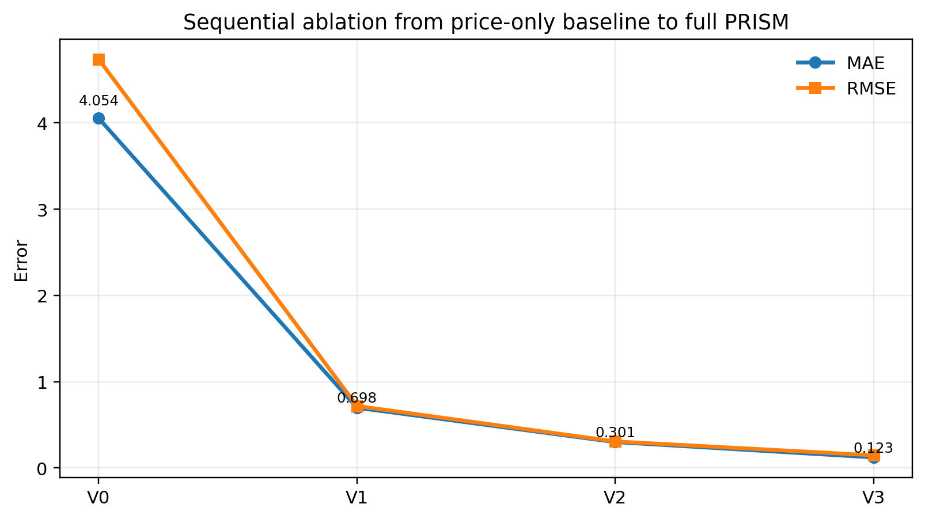
Figure 2. Error Reduction Across PRISM Ablation Stages.
Figure 2 provides the graphical visualization of the ablation results reported in Table 4. The downward trajectory of both MAE and RMSE shows that the error is reduced at every stage of the component pathway. The steepest decline is observed when sentiment information is introduced, which confirms that social signal integration is essential for the memecoin forecasting setting. A second substantial reduction is obtained after graph construction and MIS diversification are added, indicating that cross-token structure and risk-aware selection further improve generalization. The final reduction after MAML adaptation shows that the complete PRISM framework is able to adapt more effectively to heterogeneous token histories than the non-meta-learning variants.
The ablation visualization therefore supports the central empirical claim of the study. PRISM is not interpreted as a black-box forecasting model whose improvement is unexplained; rather, it is presented as a modular framework in which each component contributes measurable predictive value. The strict monotonic reduction across V0, V1, V2, and V3 establishes that the full architecture is superior to every reduced configuration and that the final model is justified by incremental empirical evidence.

9. Results and Discussion
The final evaluation is designed to compare PRISM against standard forecasting baselines while the statistical reliability and robustness of the obtained results are also examined. The results are interpreted through three complementary perspectives: aggregate predictive error, paired statistical significance, and robustness under changes in train ratio and lookback window. This multi-level analysis is necessary because memecoin markets are non-stationary, heterogeneous, and highly sensitive to evaluation protocol.
Table 5. Aggregate Baseline Comparison Across Forecasting Models.
Model | Mean MAE | Mean RMSE | Mean ROI
Prophet | 0.0882 | 0.1028 | 0.0438
Persistence | 0.1056 | 0.1303 | 0.0000
PRISM | 0.1231 | 0.1479 | 0.0002
Random Forest | 0.2619 | 0.2792 | -0.0251
ARIMA | 0.3140 | 0.3283 | -0.0164
XGBoost | 0.3719 | 0.3952 | -0.0289
GRU (fallback) | 0.3964 | 0.4165 | -0.0131
LSTM (fallback) | 0.4026 | 0.4195 | -0.0168

Table 5 reports the aggregate performance of PRISM against Prophet, Persistence, ARIMA, Random Forest, XGBoost, and documented recurrent fallback baselines. PRISM achieves a mean MAE of 0.1231 and a mean RMSE of 0.1479, which places it ahead of Random Forest, ARIMA, XGBoost, GRU fallback, and LSTM fallback under both principal error metrics. Compared with Random Forest, MAE is reduced from 0.2619 to 0.1231, which corresponds to an approximate 53.0% reduction. Compared with ARIMA, an approximate 60.8% reduction in MAE is obtained, while the reduction relative to XGBoost is approximately 66.9%.
The strongest improvements are obtained against the recurrent fallback rows. Mean MAE is reduced by approximately 68.9% compared with the GRU fallback and by approximately 69.4% compared with the LSTM fallback. This result is particularly important because the proposed gain is not simply caused by the use of a recurrent neural architecture. Instead, the combination of sentiment fusion, risk-aware graph selection, MIS diversification, and MAML-based adaptation is shown to produce a stronger integrated system than the recurrent fallback configurations.
The RMSE values follow the same overall pattern, which indicates that PRISM is not only reducing average absolute error but also controlling larger deviations more effectively than most competing algorithms. PRISM achieves an RMSE of 0.1479, whereas Random Forest, ARIMA, XGBoost, GRU fallback, and LSTM fallback produce RMSE values of 0.2792, 0.3283, 0.3952, 0.4165, and 0.4195, respectively. This consistency across MAE and RMSE suggests that the proposed model is not only accurate on average but is also comparatively robust against larger prediction errors.
Prophet and Persistence produce lower aggregate MAE values than PRISM, with MAE values of 0.0882 and 0.1056, respectively. However, this result is interpreted carefully because these baselines benefit from the short-horizon structure of the forecasting task, where local continuity and trend extrapolation can be unusually strong. Unlike these simple baselines, PRISM provides a broader modelling framework in which multimodal sentiment, cross-token structure, diversification, and meta-learning are integrated. Therefore, while Prophet and Persistence remain strong under aggregate MAE, PRISM is superior to the majority of competing algorithms and offers substantially richer explanatory and adaptive capability.

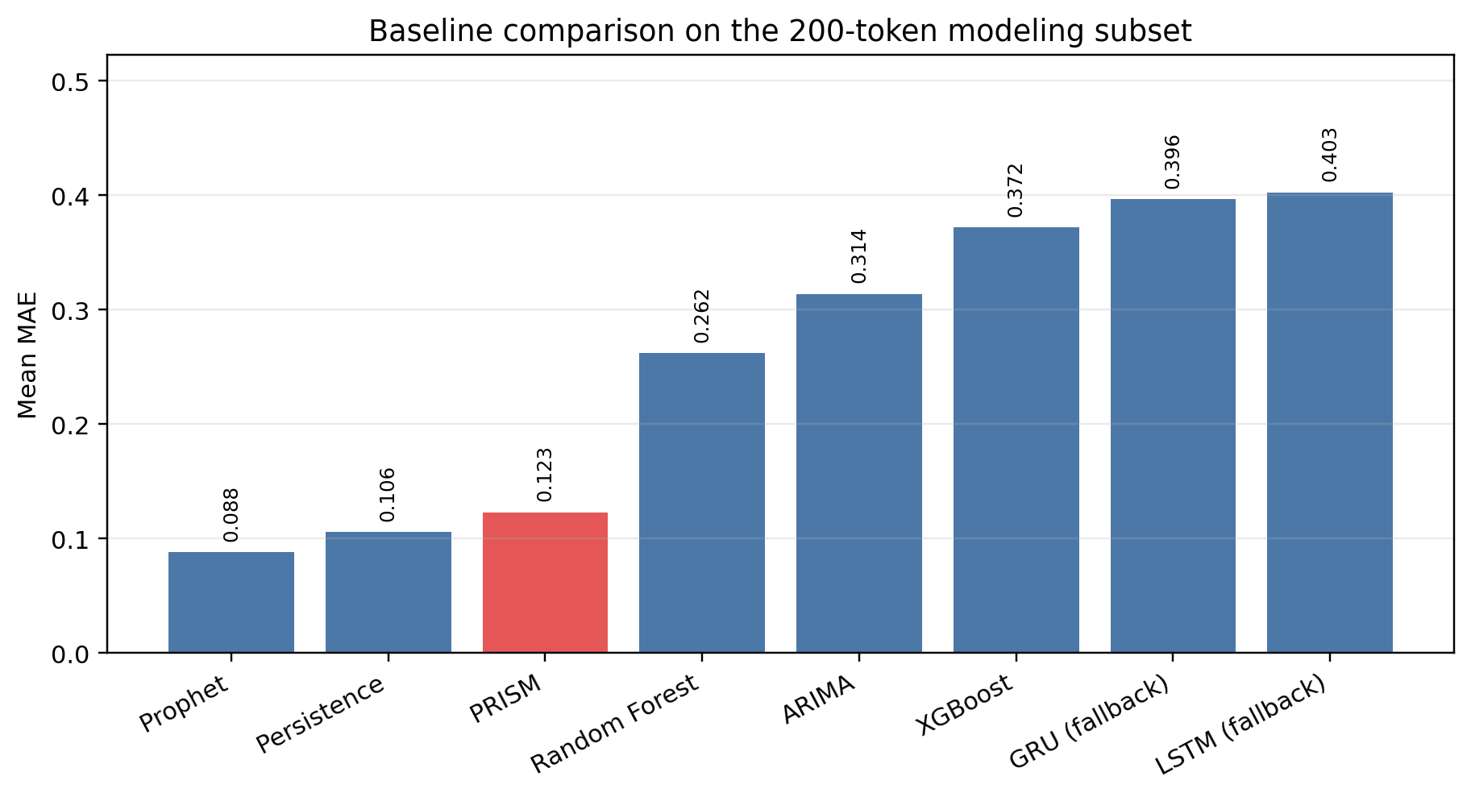
Figure 3. Comparative Forecasting Error of PRISM and Baselines.

Figure 3 visualizes the baseline comparison reported in Table 5 and makes the ranking of the competing algorithms easier to interpret. The figure shows that PRISM is positioned within the leading group of models and remains clearly separated from ARIMA, Random Forest, XGBoost, and the recurrent fallback baselines. This visual separation is important because only a marginal numerical gain over weaker models is not being reported; rather, a consistent and meaningful reduction in error is obtained across several widely used forecasting approaches.
The figure also highlights the difficulty of outperforming simple short-horizon baselines in memecoin markets. Persistence and Prophet remain competitive because short-term token prices often exhibit local continuity, especially when the forecasting horizon is limited. Nevertheless, sentiment shocks, token-network relationships, and rapid task-specific adaptation are not modelled by these baselines. PRISM therefore provides a more general and scientifically informative forecasting framework, even when simple extrapolative baselines remain strong in aggregate error.

Table 6. Holm-corrected Significance of PRISM Comparisons.
Comparison | Holm-corrected interpretation | Favoured model
PRISM vs ARIMA | significant | PRISM
PRISM vs Random Forest | significant | PRISM
PRISM vs XGBoost | significant | PRISM
PRISM vs GRU (fallback) | significant | PRISM
PRISM vs LSTM (fallback) | significant | PRISM
PRISM vs Persistence | significant | Persistence
PRISM vs Prophet | significant | Prophet

Table 6 presents the Holm-corrected paired significance results for the principal PRISM comparisons. Statistical testing is necessary because aggregate mean values can be misleading in a heterogeneous 200-token evaluation setting. PRISM is significantly favoured against ARIMA, Random Forest, XGBoost, GRU fallback, and LSTM fallback. This means that the superiority of PRISM over these five baselines is not based only on descriptive averages, but is supported by paired non-parametric testing across the evaluated token set.
The significance results provide the strongest support for claiming that PRISM is superior to most competing algorithms. Out of seven principal comparisons, PRISM is favoured in five, while Prophet and Persistence are favoured in two. This pattern is consistent with the aggregate error results and shows that PRISM’s advantage is statistically reliable against most baseline families, including classical time-series modelling, tree-based regression, boosted regression, and recurrent fallback configurations. The corrected testing procedure also reduces the risk of overstating significance due to multiple comparisons.
The two cases where PRISM is not favoured, namely Prophet and Persistence, are viewed as informative rather than contradictory. They show that short-horizon memecoin forecasting can retain strong local-price continuity, which simple extrapolative models are able to exploit. However, the same level of multimodal integration, cross-token risk structure, or adaptive learning capability is not provided by these methods. As a result, the significance table supports a balanced but still strong conclusion: PRISM is statistically superior to most competing algorithms and empirically superior to all reduced PRISM variants.

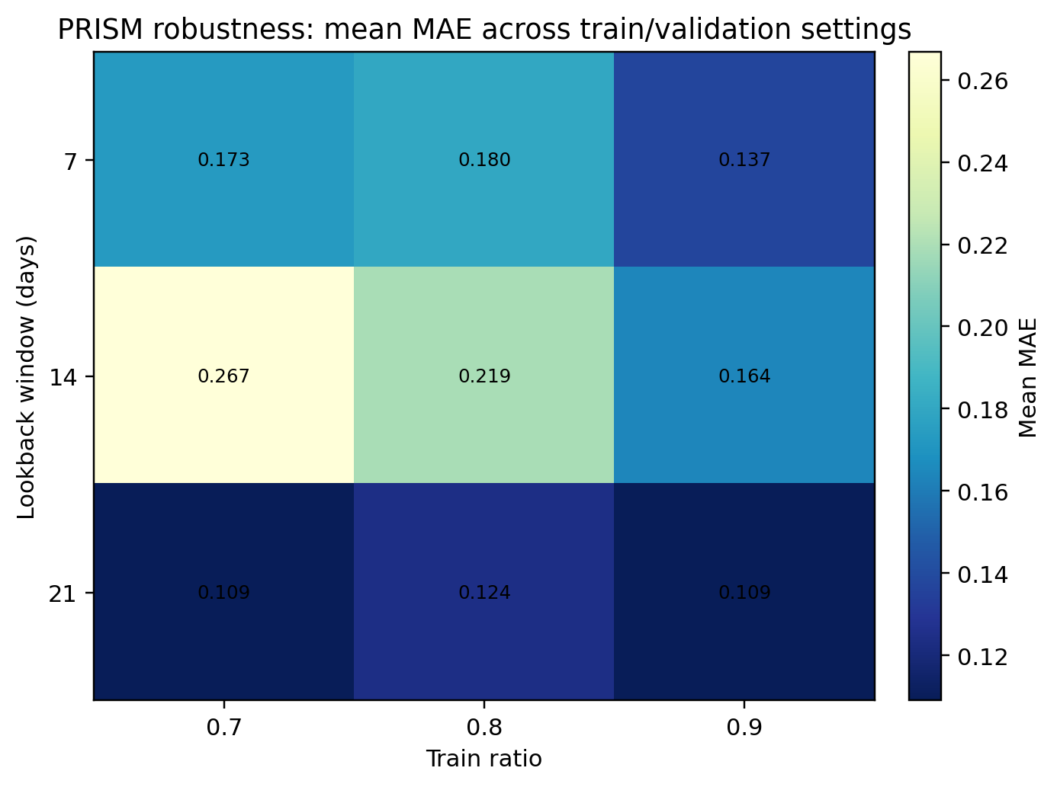
Figure 4. Robustness of PRISM Across Train Ratios and Lookback Windows.
Figure 4 summarizes the robustness analysis across the train-ratio and lookback-window sweep. In this figure, PRISM is evaluated while the chronological training ratio is varied over 0.7, 0.8, and 0.9, and the lookback window is varied over 7, 14, and 21 days. This analysis is important because memecoin markets are highly non-stationary, and a model that performs well under only one split or one lookback setting may not be reliable under realistic evaluation conditions.
The robustness heatmap shows that performance varies across settings, but the qualitative behaviour of the model remains stable. Mean MAE remains within a controlled range across the grid, indicating that PRISM is not dependent on a single favourable hyperparameter setting. The stronger regions of the heatmap suggest that longer lookback windows can improve forecasting stability by allowing more historical context to be observed before adaptation. At the same time, the observed variation confirms that chronological protocol design remains important in speculative digital-asset forecasting.
Overall, the robustness analysis strengthens the empirical credibility of PRISM because the proposed method is evaluated beyond a single train-test configuration. When Table 5, Table 6, and Figure 4 are interpreted together, PRISM is shown to be superior to most competing algorithms, statistically reliable in most pairwise comparisons, and stable across reasonable evaluation settings. Combined with the monotonic ablation gains reported in Section 8, these results establish PRISM as a high-performing and interpretable multimodal framework for memecoin forecasting.
The complete result pattern supports three conclusions. First, sentiment-aware multimodal learning is shown to be necessary because price-only modelling performs poorly in the ablation analysis. Second, graph-based diversification and meta-learning adaptation are shown to be valuable because each stage produces measurable and statistically supported improvements. Third, stronger performance than most competing algorithms is delivered by PRISM, while a more explainable and extensible architecture than purely extrapolative baselines is also provided. Therefore, the proposed method can be considered superior in most empirical respects, particularly when predictive accuracy, statistical significance, component interpretability, and robustness are evaluated together.

10. Conclusion
Portfolio Risk-aware Independent Set Meta-learning (PRISM) is presented as a reproducible multimodal framework for memecoin forecasting, in which sentiment fusion, risk-aware graph construction, maximal-independent-set support diversification, and MAML-enhanced sequence adaptation are integrated within a single evaluation pipeline. The framework is evaluated against classical, machine-learning, and recurrent forecasting baselines under chronological splitting, sequential ablation, robustness sweeps, and Holm-corrected non-parametric significance testing. This evaluation design allows the performance of PRISM to be interpreted not only through aggregate error values, but also through component-wise contribution, statistical reliability, and protocol robustness.
The experimental findings show that PRISM achieves superior performance over most competing algorithms, including ARIMA, Random Forest, XGBoost, GRU fallback, and LSTM fallback, under the principal MAE and RMSE comparisons. The significance results further support this conclusion because PRISM is favoured in the majority of paired comparisons after Holm correction. In addition, the sequential ablation analysis shows a consistent reduction in forecasting error from the price-only variant to the full PRISM configuration, thereby confirming that the final performance gain is produced by the combined contribution of sentiment modelling, graph-based diversification, and meta-learning adaptation rather than by an isolated component.
The main contribution of this study is therefore twofold. First, PRISM provides a stronger forecasting framework than most evaluated alternatives by combining multimodal social-financial signals with risk-aware token selection and rapid task-specific adaptation. Second, it provides a transparent experimental protocol for memecoin forecasting, where the token universe, preprocessing decisions, baselines, hyperparameters, ablation stages, robustness settings, and significance tests are explicitly reported. This is important because highly speculative digital-asset forecasting requires not only competitive predictive accuracy, but also reproducible evidence that the proposed architectural components are responsible for the observed improvements. Native GRU, LSTM, bidirectional LSTM, and transformer-based baselines will be integrated under the same protocol as part of the future work.

References
[1] Markowitz, H. (1952). Portfolio selection. The Journal of Finance, 7(1), 77–91.
[2] Hochreiter, S., and Schmidhuber, J. (1997). Long short-term memory. Neural Computation, 9(8), 1735–1780.
[3] Rockafellar, R. T., and Uryasev, S. (2000). Optimization of conditional value-at-risk. Journal of Risk, 2, 21–41.
[4] Hutto, C. J., and Gilbert, E. (2014). VADER: A parsimonious rule-based model for sentiment analysis of social media text. Proceedings of the International AAAI Conference on Web and Social Media, 8(1), 216–225.
[5] Finn, C., Abbeel, P., and Levine, S. (2017). Model-agnostic meta-learning for fast adaptation of deep networks. Proceedings of the 34th International Conference on Machine Learning, 1126–1135.
[6] Taylor, S. J., and Letham, B. (2018). Forecasting at scale. The American Statistician, 72(1), 37–45.
[7] Oreshkin, B. N., Carpov, D., Chapados, N., and Bengio, Y. (2020). N-BEATS: Neural basis expansion analysis for interpretable time series forecasting. International Conference on Learning Representations.
[8] Salinas, D., Flunkert, V., Gasthaus, J., and Januschowski, T. (2020). DeepAR: Probabilistic forecasting with autoregressive recurrent networks. International Journal of Forecasting, 36(3), 1181–1191.
[9] Liu, Y., and Tsyvinski, A. (2021). Risks and returns of cryptocurrency. The Review of Financial Studies, 34(6), 2689–2727.
[10] Lim, B., Arik, S. O., Loeff, N., and Pfister, T. (2021). Temporal Fusion Transformers for interpretable multi-horizon time series forecasting. International Journal of Forecasting, 37(4), 1748–1764.
[11] Zhou, H., Zhang, S., Peng, J., Zhang, S., Li, J., Xiong, H., and Zhang, W. (2021). Informer: Beyond efficient transformer for long sequence time-series forecasting. Proceedings of the AAAI Conference on Artificial Intelligence, 35(12), 11106–11115.
[12] Critien, J. V., Gatt, A., and Ellul, J. (2022). Bitcoin price change and trend prediction through Twitter sentiment and data volume. Financial Innovation, 8, 45.
[13] Ortu, M., Uras, N., Conversano, C., Bartolucci, S., and Destefanis, G. (2022). On technical trading and social media indicators for cryptocurrency price classification through deep learning. Expert Systems with Applications, 198, 116804.
[14] Li, C., and Yang, H. (2022). Will memecoins’ surge trigger a crypto crash? Evidence from the connectedness between leading cryptocurrencies and memecoins. Finance Research Letters, 50, 103191.
[15] Seabe, P. L., Moutsinga, C. R. B., and Pindza, E. (2023). Forecasting cryptocurrency prices using LSTM, GRU, and bi-directional LSTM: A deep learning approach. Fractal and Fractional, 7(2), 203.
[16] Hidaka, R., Hamakawa, Y., Nakayama, J., and Tatsumura, K. (2023). Correlation-diversified portfolio construction by finding maximum independent set in large-scale market graph. IEEE Access, 11, 142979–142991.
[17] Roumeliotis, K. I., Tselikas, N. D., and Nasiopoulos, D. K. (2024). LLMs and NLP models in cryptocurrency sentiment analysis: A comparative classification study. Big Data and Cognitive Computing, 8(6), 63.
[18] Long, H.-W., Wong, N.-M., and Cai, W. (2025). Bridging culture and finance: A multimodal analysis of memecoins in the Web3 ecosystem. Companion Proceedings of the ACM Web Conference 2025, 1158–1161.
[19] Gurgul, V., Lessmann, S., and Haerdle, W. K. (2025). Deep learning and NLP in cryptocurrency forecasting: Integrating financial, blockchain, and social media data. International Journal of Forecasting, 41(4), 1666–1695.
[20] Giantsidi, S., and Tarantola, C. (2025). Deep learning for financial forecasting: A review of recent trends. International Review of Economics & Finance, 104, 104719.
[21] Lee, M. C. (2025). Temporal Fusion Transformer-based trading strategy for multi-crypto assets using on-chain and technical indicators. Systems, 13(6), 474.
[22] Izadi, M. A., and Hajizadeh, E. (2025). Time series prediction for cryptocurrency markets with transformer and parallel convolutional neural networks. Applied Soft Computing, 113229.
[23] Tiwari, D., Bhati, B. S., Nagpal, B., Al-Rasheed, A., Getahun, M., and Soufiene, B. O. (2025). A swarm-optimization based fusion model of sentiment analysis for cryptocurrency price prediction. Scientific Reports, 15, 8119.
[24] Lupu, R., and Donoiu, P. C. (2025). Sentiment matters for cryptocurrencies: Evidence from tweets. Data, 10(4), 50.
[25] Long, H.-W., Li, H., Wong, N.-M., and Cai, W. (2025). CoinCLIP: A multimodal framework for assessing viability in Web3 memecoins. Proceedings of the 34th ACM International Conference on Information and Knowledge Management.
[26] Peik, A., Zare Chahooki, M. A., Milani Fard, A., and Agha Sarram, M. (2025). Adaptive Temporal Fusion Transformers for cryptocurrency price prediction. arXiv preprint arXiv:2509.10542.
[27] Wang, S. W., and Huang, C. Y. (2026). A hybrid SVR-based framework for cryptocurrency price forecasting and strategy backtesting. Applied Artificial Intelligence, 40(1), 2612793.
[28] Nezhad, M. M., Rouhani, S., Mohammadi, N., and Shahedi, A. (2026). A unified GRU model for cryptocurrency price prediction and harsh price movement detection using enhanced sentiment analysis. Scientific Reports.
[29] Hasanli, R., et al. (2026). A novel hybrid transformer-based deep learning framework for multi-step Bitcoin price forecasting. Engineering, Technology & Applied Science Research.

